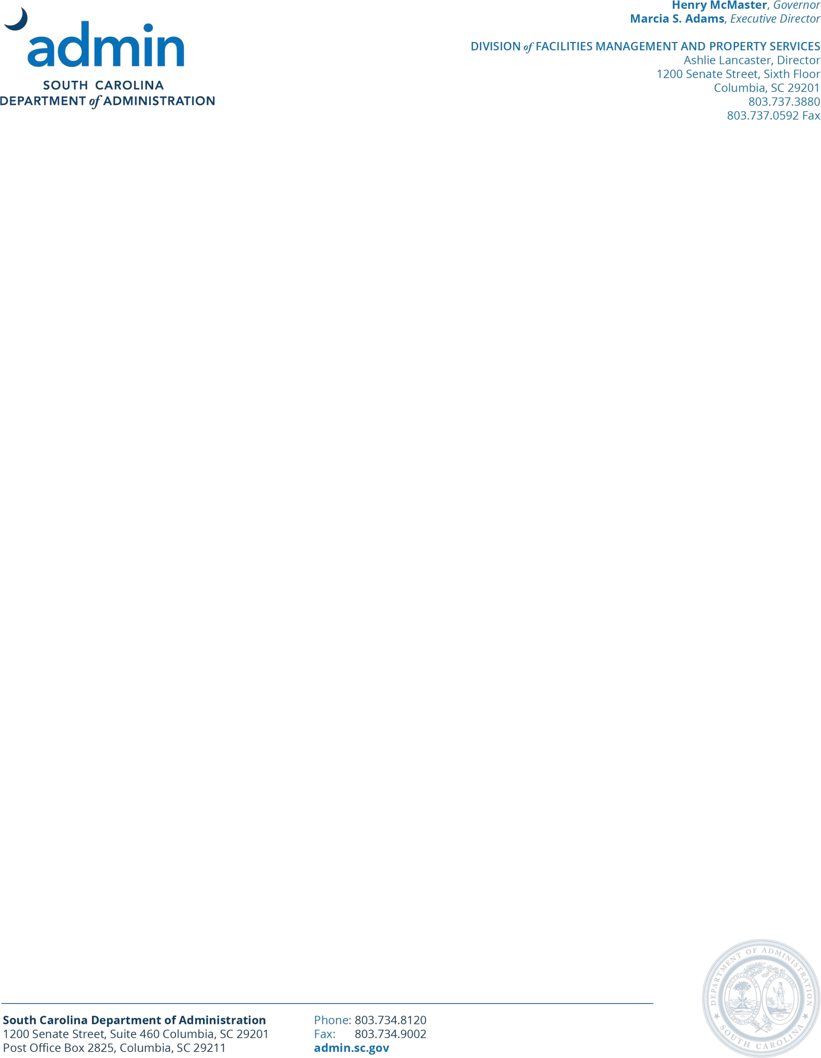

April 3, 2026

Dear Property Owner or Agent:
The State of South Carolina is seeking Office space in Horry County. Attached is a summary of specifications and lease criteria. You are invited to submit a proposal to lease property to the State which may meet the criteria.

Please submit proposals to the Department of Administration, Real Property Services on or before

4:00 PM, April 24, 2026.

The agency and Real Property Services will determine which proposals best suit the agency’s needs. After the deadline, we will review all proposals submitted. Should your proposal be of interest, you will be contacted to schedule a meeting and view the property.
All inquiries regarding this lease solicitation should be directed to Real Property Services via e-mail at rps@admin.sc.gov.

To be eligible to submit a proposal, a property owner or agent must have submitted to Real Property Services a receipt and acknowledgment of S.C. Code of Laws, 1976, as amended, §§1-11-55, 1-11-56, and 1-11-65 and S.C. Code of Regulations, §19-447.1000. If you have not done so and wish to respond with a proposal, you may download the applicable form from our website at: FMPS-202C.docx.

Sincerely,

Real Property Services

REQUEST FOR LEASE PROPOSAL FOR
SOUTH CAROLINA DEPARTMENT OF CHILDREN’S ADVOCACY

OFFICE SPACE IN HORRY COUNTY

No lease agreement with the State is final without the approval of designated authorities as governed by South Carolina law. Real Property Services reserves the right to negotiate lease terms with submitting parties until such final approval is granted. State law prohibits any party participating in this solicitation process from making direct contact with the agency seeking space until a final lease has been approved. All correspondence should be directed to Real Property Services. Prior to lease negotiation, Landlord may be required to provide a list of all partners or members where Landlord is an LLC or partnership (to include all tiers so that individuals are named).
Properties selected for site visits will be chosen based on a cost analysis of the submitted proposals, the responsiveness of the proposals to the stated requirements, and the space efficiency of proposed floor plans submitted; therefore, best proposals should be submitted initially.

LEASE CRITERIA – SOUTH CAROLINA DEPARTMENT OF CHILDREN’S
ADVOCACY
- Location: Horry County (Myrtle Beach), South Carolina
- Expected occupancy date: June 15, 2027
- Total space needed is approximately 2,000 rentable square feet +/- depending on circulation and common area factor. Please include both rentable and usable square feet in proposal and include the common area factor (%).
- Ideal set up should include, but is not limited to:
  - 2 private offices for professional staff of approximately 120 square feet each
  - Area for 6 workstations of approximately 48 square feet
*proposal should include cost with and without workstations provided by Landlord
  - 1 small reception area of approximately 50 square feet to accommodate a minimum seating area of 2 people
  - 1 small break room with seating for 4 people of approximately 120 square feet.
  - 1 print alcove to include 6 linear feet of upper and lower cabinets for supply storage and printer of approximately 24 square feet each
  - 1 IT closet with temperature control of approximately 40 square feet
  - 1 medium conference room of approximately 250 square feet to accommodate 6-8 people at a time
- Landlord is responsible for ensuring that any space proposed meets all American Disabilities Act (ADA) requirements and shall be responsible for all costs associated with ADA compliance.
- Cabling must be certified to CAT-6 standards, with all terminations by the Landlord. All internet connections, phone/data connections, electrical and other outlets to be provided by the Landlord throughout the space as specified by Agency with the ability to access network via fiber optic connection and support VOIP.
- 13 parking spaces are required. State availability of reserved parking.
- Parking lot must be paved and lighted.
- Tenant shall have 24/7 access to demised premises with HVAC operational afterhours and on Weekends *proposal should include HVAC operational details
- Landlord shall provide secure building access (card access preferred) and shall allow Tenant to install security cameras within demised premises as well as entrance code lock
- Term: Please provide proposed rates for 3, 5, 7 or 10-year terms.

- Proposals should be for a GROSS lease to include all operating expenses, including utilities, janitorial services and supplies, grounds maintenance, repairs, taxes, insurance, general building maintenance, building equipment maintenance, electrical systems maintenance, HVAC maintenance, plumbing maintenance and any other service necessary to maintain and operate all building and site improvements.
- The following proposals are not preferred and may be eliminated from consideration. Proposals that require:
- the pass-through of any increases in operating expenses above the amount included in the rent rate.
- reimbursement of tenant improvement costs upon early termination
- use of a lease form that differs from the Standard State Lease form (standard state lease form found here or available upon request).

MINIMUM STATE REQUIREMENTS
- Property must be barrier free, hazard free and smoke free.
- Property must meet zoning requirements for proposed use.
- Economical and efficient space utilization.

PROPOSAL DUE DATE AND REMITTANCE INSTRUCTIONS:

- Please submit proposals to the Department of Administration, Real Property Services on or before 4:00 PM, April 24, 2026.
- All proposals must be in writing and may be submitted by mail or e-mail. (It is agent’s
responsibility to ensure receipt). Please submit proposals on the FMPS-202E form.
- Proposals should specify floor usable and rentable square feet (if applicable) and should be calculated according to the ANSI/BOMA-Z65.1-1996 standard.
- Please attach a proposed floor plan.

CONTACT INFORMATION
All information and questions should be directed to Real Property Services – no direct contact can be made with South Carolina Department of Children’s Advocacy
Direct contact can be cause for automatic disqualification.

RETURN PROPOSALS AND DIRECT ALL QUESTIONS TO:
DEPARTMENT OF ADMINISTRATION REAL PROPERTY SERVICES
1200 SENATE STREET, 6th Floor COLUMBIA, SC 29201
PHONE: 803-737-0644 or 803-737-8731
EMAIL: rps@admin.sc.gov

